Assignment 1 of DevOps and SCM

**Name- Ujjwal Kumar Gupta**

**SAP ID- 500091584**

Ques 1 Simple array

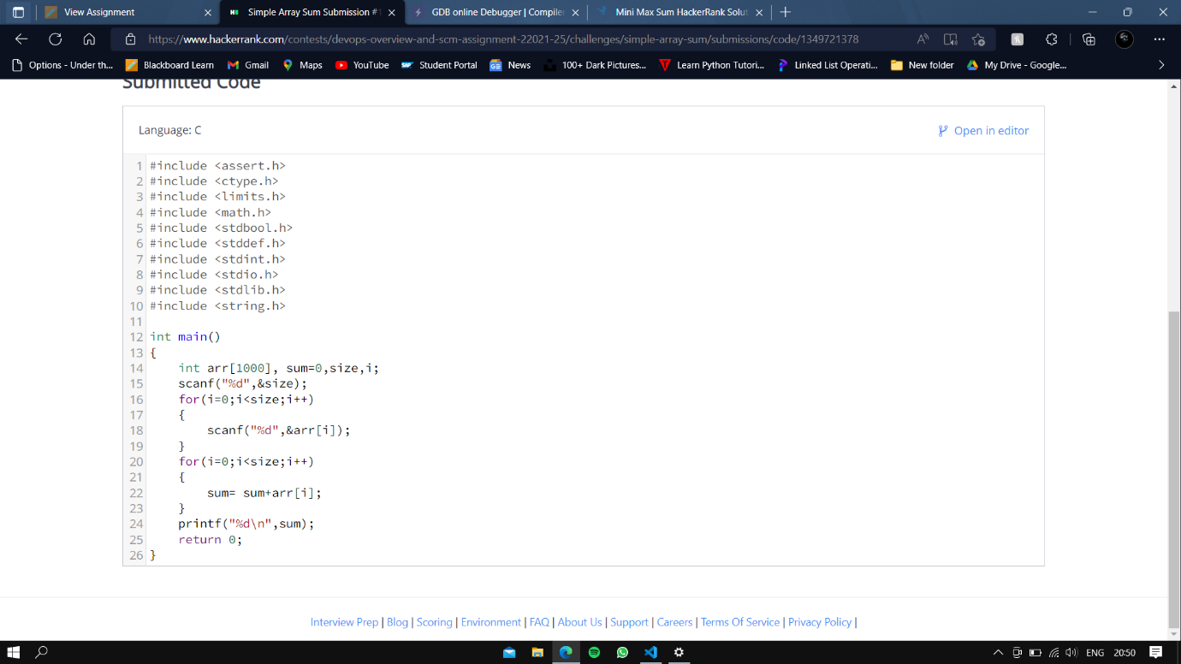

Ques 2 Mini-Max

